CYCLE 5

Functions to familiarize:
- Linear SVC The objective of a Linear SVC (Support Vector Classifier) is to fit to the data you provide, returning a "best fit" hyperplane that divides, or categorizes, your data. From there, after getting the hyperplane, you can then feed some features to your classifier to see what the "predicted" class is.

- CountVectorizer:
Creates a matrix in which each unique word is represented by a column of the matrix, and each text sample from the document is a row in the matrix. The value of each cell is nothing but the count of the word in that particular text sample.

Given a data set of support tickets. Each ticket also has an associated "urgency score" of between 0 and 3, and where 0 is "very urgent" and 3 is "not urgent". It would be useful if we could have a machine guess how urgent a ticket is, based on the description, so the urgent tickets can be resolved first

- For the given data set, perform text classification using SVM and find out the accuracy of the model.
Ref: https://www.codementor.io/blog/text-classification-6mmol0q8oj

PROGRAM:
from sklearn.feature_extraction.text import TfidfVectorizer, CountVectorizer

from sklearn.metrics import confusion_matrix
from sklearn.metrics import classification_report

from sklearn.model_selection import cross_val_score
from sklearn.model_selection import cross_val_predict
from sklearn.model_selection import train_test_split

from sklearn.svm import LinearSVC
from sklearn.tree import DecisionTreeClassifier
from sklearn import tree

with open("tickets.txt") as f:
tickets = f.read().strip().split("\n")

with open("labels_4.txt") as f:
labels = f.read().strip().split("\n")

X_train, X_test, y_train, y_test = train_test_split(tickets, labels, test_size=0.1, random_state=1337)

vectorizer = CountVectorizer()
svm = LinearSVC()
X_train = vectorizer.fit_transform(X_train)
X_test = vectorizer.transform(X_test)
_ = svm.fit(X_train, y_train)
y_pred = svm.predict(X_test)
print(classification_report(y_test, y_pred))
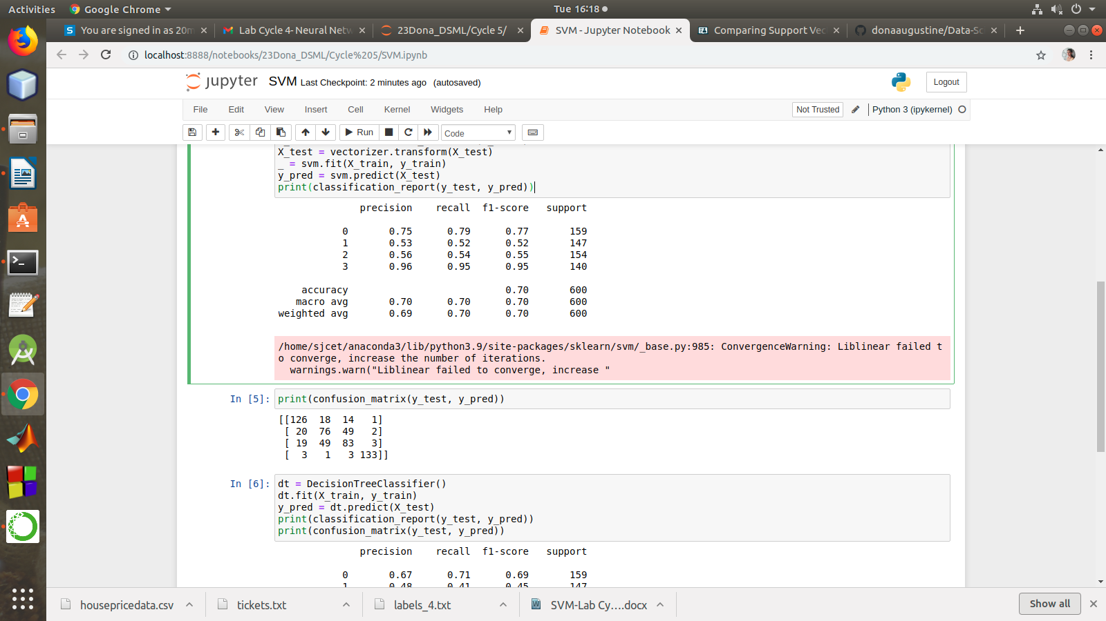

print(confusion_matrix(y_test, y_pred))

dt = DecisionTreeClassifier()
dt.fit(X_train, y_train)
y_pred = dt.predict(X_test)
print(classification_report(y_test, y_pred))
print(confusion_matrix(y_test, y_pred))

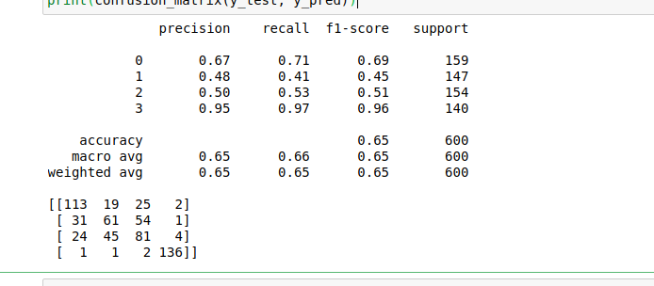

K Means
2. Given dataset contains 200 records and five columns, two of which describe the customer’s annual income and spending score. The latter is a value from 0 to 100. The higher the number, the more this customer has spent with the company in the past:
Functions to familiarize:
- The purpose of Kmeans.fit() is to train the model with data.
- The purpose of Kmeans.predict() is to apply a trained model to data
==================================================
Q. Using k means clustering create 6 clusters of customers based on their spending pattern.
- Visualize the same in a scatter plot with each cluster in a different color scheme.
- Display the cluster labels of each point.(print cluster indexes)
- Display the cluster centers.
- Use different values of K and visualize the same using scatter plot

References:
https://www.atmosera.com/blog/unsupervised-learning-with-k-means-clustering-part-ii/
https://nickmccullum.com/python-machine-learning/k-means-clustering-python/

PROGRAM:
from sklearn.cluster import KMeans
from sklearn.datasets import make_blobs
import numpy as np
import matplotlib.pyplot as plt
import seaborn as sns
sns.set()
%matplotlib inline

import pandas as pd
customers = pd.read_csv('customer_data.csv')
customers.head()

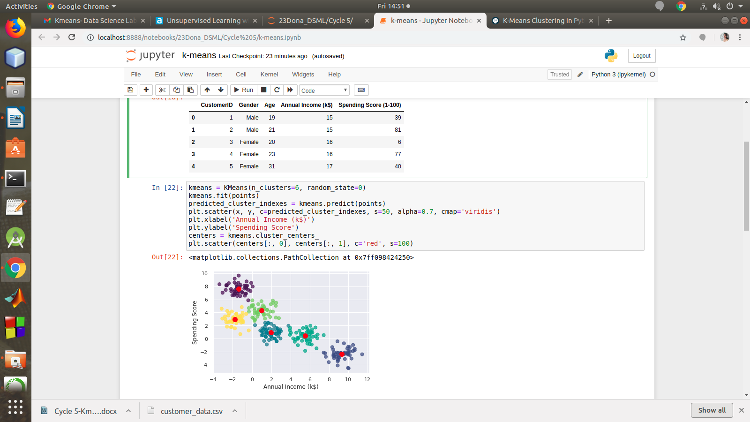

points = customers.iloc[:, 3:5].values
x = points[:, 0]
y = points[:, 1]
plt.scatter(x, y, s=50, alpha=0.7)
plt.xlabel('Annual Income (k$)')
plt.ylabel('Spending Score')

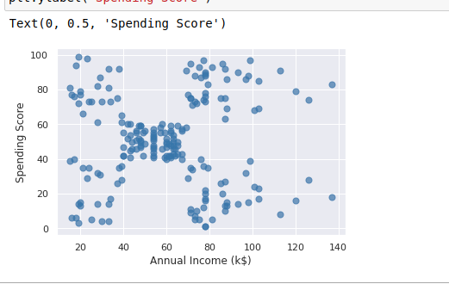

kmeans = KMeans(n_clusters=6, random_state=0)
kmeans.fit(points)
predicted_cluster_indexes = kmeans.predict(points)
print(predicted_cluster_indexes)
plt.scatter(x, y, c=predicted_cluster_indexes, s=50, alpha=0.7, cmap='viridis')
plt.xlabel('Annual Income (k$)')
plt.ylabel('Spending Score')
centers = kmeans.cluster_centers_
plt.scatter(centers[:, 0], centers[:, 1], c='red', s=100)

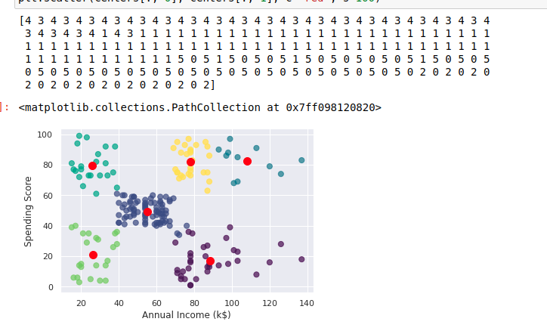

kmeans = KMeans(n_clusters=3, random_state=0)
kmeans.fit(points)
predicted_cluster_indexes = kmeans.predict(points)
plt.scatter(x, y, c=predicted_cluster_indexes, s=50, alpha=0.7, cmap='viridis')
plt.xlabel('Annual Income (k$)')
plt.ylabel('Spending Score')
centers = kmeans.cluster_centers_
plt.scatter(centers[:, 0], centers[:, 1], c='red', s=100)

